Exercise can keep brain fit in over‑50s

**Tom Whipple, Science Editor**

April 25 2017, 12:01am, The Times

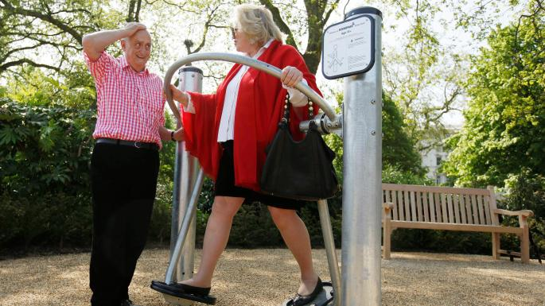

About 45 minutes of exercise can help improve cognitive abilities and memorySTEFAN WERMUTH/REUTERS

Share

Save

Over-fifties should be prescribed exercise to keep their brains sharp, scientists have said. Their advice comes after one of the largest studies into the effects of exercise on the brain found that 45 minutes of swimming, cycling, weight training or similar exercise helps to boost thinking, concentration and memory skills.

For the research, published in the *British Journal of Sports Medicine*, scientists from the University of Canberra analysed 39 previous studies. They said the results showed that whatever people’s level of brain health, exercise always helped. Aerobic exercise was found to be good for improving general cognitive abilities, while resistance training helped memory.

The scientists suggested that a mixture of the two was ideal and that people should aim for an exercise programme with components of both “of at least moderate intensity and at least 45 minutes per session, on as many days of the week as possible”.

**Wiki ‘real news’ service**  
Jimmy Wales, the Wikipedia founder, is launching a crowdfunded news service in an attempt to combat fake news. The internet entrepreneur said that professional journalists and community contributors would produce “fact-checked, global news stories” for the Wikitribune site. It will be free to use but Mr Wales hopes that monthly donations from supporters will lower the news media’s reliance on advertising and “the incessant drive for clicks”.

**Heart attack test misses beat**  
Thousands of heart attacks are missed every year because hospitals are not using a standard test in the best way, a study has concluded.

Heart attacks are diagnosed by giving patients complaining of chest pain a blood test when they arrive at hospital and again after three hours. The test looks for a protein called troponin, which is released by injured heart muscles. If levels in the blood are below a certain level a heart attack is ruled out. Now doctors are able to use more sensitive troponin tests to detect abnormal rises even below this threshold in about one in 20 patients.

In a study of 1,218 patients in Edinburgh, 16 per cent of whom turned out to have had a heart attack, standard methods missed 20 cases, against four using the new method, researchers report in the journal *Circulation*.

“Given heart attacks are the single leading cause of death in the UK, we believe our findings will improve care for patients,” Andrew Chapman, of the University of Edinburgh and lead author of the study, said.

**Millions of children lack food in school holidays**Up to three million children risk going hungry during school holidays, the all-party parliamentary group on hunger says. It cites evidence of children living on crisps, being too weak to play sport and returning to school malnourished. It urged the government to use £100,000 from the tax on sugary drinks to support food schemes when schools are closed.

**Scotland Yard unit will tackle online hate crime**  
Britain’s first police unit dedicated to tackling online hate crime has been launched by Sadiq Khan, the mayor of London. Five Scotland Yard officers led by a detective inspector will gather intelligence, test new investigative methods and work with community experts. In 2015-16 forces in England and Wales were recording about 170 hate crimes a day.

**Missing nurse appeal**  
Police are appealing for help in finding a trainee nurse who went missing nearly two weeks ago. Anna Lewis, 27, was last seen at 12.15pm on April 13, leaving Southmead Hospital in Bristol, where she was on a placement. The disappearance was described as out of character. Police released pictures of Miss Lewis, who is from the Fishponds ara of Bristol, and described her as white, 5ft 5in to 5ft 6in, slim, with brown eyes and long, dark-brown hair which she wears in a ponytail.

**Shark mercy flight**  
Frances Gonsalves, 40, a British woman who was attacked by a shark while snorkelling at a beach in Ascension Island, St Helena, on Saturday, is to be flown to Britain for urgent treatment. Her husband, who was in the water with her, managed to fight off the shark — watched by their two children on the beach. St Helena is a British Overseas Territory off the west coast of Africa.

**Jail sentence warning**  
Proposals to overhaul how courts deal with offenders breaking the terms of non-custodial punishments could drive up the prison population, MPs warn. The justice select committee argues that the Sentencing Council has produced draft guidelines with “inadequate data” on how courts deal with such offences and the prospect of more offenders receiving jail sentences.

**Plastic-eating worms**  
Waxworms could offer a solution to the eight million tonnes of plastic waste deposited in the oceans every year, which does not biodegrade so ends up in the food chain or forms rubbish islands. The waxworm, used as fish bait, can digest plastic. In *Current Biology*, researchers from Cantabria, Spain, and Cambridge University express hope of replicating the chemical process.

**‘My colour helped me’** Andi Oliver, the new host of BBC2’s *Great British Menu*, has admitted that positive discrimination helped her get her job. The 53-year-old presenter, who has replaced Prue Leith after she left to become a judge on the *Great British Bake Off*, said: “Well, one of the reasons is because I am a black woman and not only that, I’m a middle-aged black woman,” she said.

**Early puberty ‘increases risk of cancer later in life’**  
Children who enter puberty early are at greater risk of getting cancer in later life, according to a study. The researchers believe that increased levels of sex hormones trigger cancer of the breast, ovary, womb and prostate. These diseases are known to be caused by sex hormones.

After analysing genetics data from countries including the UK, the team at the Medical Research Council Epidemiology Unit at Cambridge University found that the puberty link held even when taking into account body weight, which can affect both the timing of puberty and cancer risk.

They have also established that 398 inherited genes determine the age at which children reach sexual maturity — four times the number previously known. Early puberty is considered to be age eight for boys and ten for girls. The study is published in*Nature Genetics.*

**Ball from ‘greatest Test’ will be a prize catch at £12,000**The cricket ball bowled by the England player Bob Willis in the so-called greatest Test in the 1981 Ashes series is tipped to sell for £12,000. He took eight wickets in Australia’s second innings, helping his team to victory against odds of 500-1. He kept the ball after the match, inscribed it “Headingley 1981. Bob Willis 8-43” and signed it. He sold it to a private collector of cricketing memorabilia who died recently.

It will be sold with a special medallion awarded to Willis by the match sponsors, Cornhill Insurance, and his standard Test series medal. Tim Knight, of Knights Auctioneers in Norwich, where the sale will take place on May 13, said: “This was a remarkable and significant match in the history of the Ashes.”